**The Lobuzz:**

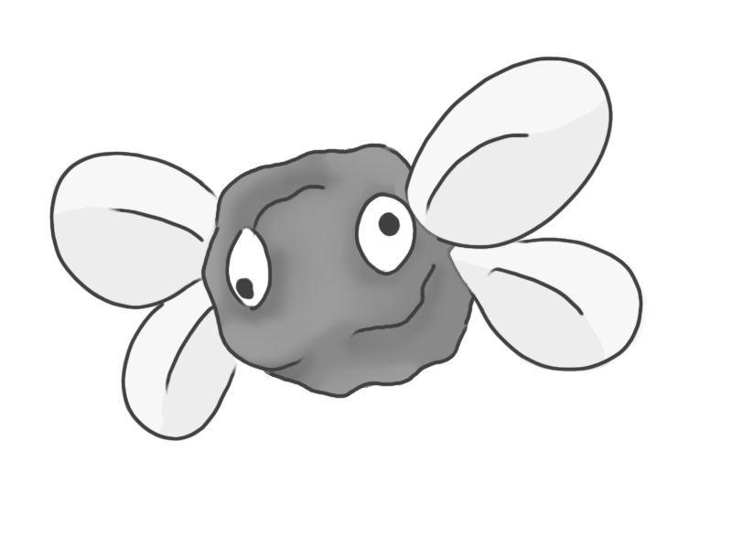

**Brief Synopsis**

The Lobuzz is an enemy based off a ball of playdoh with googly eyes and paper wings attached, they could also have string holding them up as if attached to the sky further exaggerating the idea of the game being within a child’s imagination. These enemies are exceptionally weak and would in most cases die in one hit. The player could use these enemies to tether to when using the grapple-shot, allowing them to reach higher places. On death, this enemy will lose its flight and plummet towards the floor.

**Variants**

To differentiate between these variants the colour of the playdoh at the core of the enemy will alter

**Yellow:**

* The enemy does not move and hovers in place.

**Blue:**

* This enemy moves along a predefined patrol route.

**Green:**

* When in range, the enemy moves towards the player to deal contact damage.

**Red:**

* When in range, the enemy moves towards the player and explodes on contact.

**AI**

The Pathfinding this enemy will require the use of an algorithm such as A*, this will only be used on variants **Red** and **Greed**. **Blue** however will follow a path and **Yellow** will not use any form of AI.

**Animations**

The Lobuzz will have an exceptionally simple animation, only its wings will move no matter what variant.  
 **Idle:**

* The enemy’s body will not change shape, instead its wings will just move up and down.

**Death:**

* It will fall out the air.

**Average Size**

